This is the title of an interesting presentation
A. Familyname^{1,2}, B. Familyname², and C. Familyname³

¹ Laboratory, Address, City, Country (12pt italic)
² Laboratory, Address, City, Country (12pt italic)
³ Laboratory, Address, City, Country (12pt italic)
contact@email.com

The abstract starts here, after a double vertical space. Please use only Times New Roman font 11 pts. Do not change the formatting (paper size=A4, margins=2.5cm at top, bottom, left and right sides) do not include any header or footer; do not include any page number, but a blank space at the footer to include it at the printer.

Include a blank line between paragraphs. The entire abstract must fit a maximum of two single pages.

If you would like to include a figure, place it inside the text followed with its caption, as illustrated in Fig. 1. Eventual references may be included at the end of the page, using this format [1].

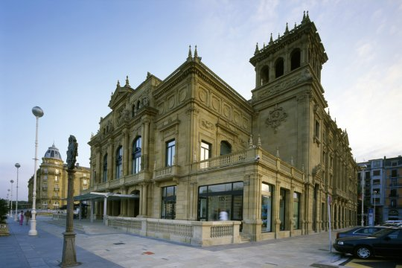

Fig. 1: Image number 1.

To produce a high quality Adobe PDF file from this document, please select the following Adobe PDF options:
- Default setting = Press Quality
- Adobe PDF Page Size = A4

[1] A. Familyname, B. Familyname, and C. Familyname, Appl. Phys. Lett. XX, xxx (2012).

(Leave a blank space here)

